Lab Session
Week 3
Objective:
Today you will learn to organize complex robot data using nested dictionaries, save and load structured files for logging patrols, simulate realistic sensor noise and glitches, and analyze collected data to trigger alerts. These skills are directly applicable to controlling robots, logging their activities, and reacting to their environment.
Students work individually. Save all your code in a Week 3 folder in the same repository structure you set up for Week 1.

Advanced Python Refresher
Part 1 - Nested Dictionaries for Robot Data
Dictionaries can store more than simple values, they can store lists or even other dictionaries. This is useful for recording multiple readings from each sensor.
Example:
sensors = {
"front": [12.5, 11.8, 10.2],
"left": [8.3, 8.5, 8.6],
"right": [14.1, 13.7, 13.0]
}
for sensor, readings in sensors.items():
change = readings[-1] - readings[0]
print(f"{sensor} change: {change:.1f} cm")

Note: This code calculates the change in sensor readings by subtracting the first value from the last value in each list (readings[-1] - readings[0]). The key technique is using negative indexing ([-1]) to access the last element without knowing the list length, and the .items() method to unpack both dictionary keys and values in the loop.

Exercise 1:
Create robot_log.py:
1. Ask the user for 3 readings for each of 3 sensors: front, left, right.
2. Store them in a nested dictionary (sensor name → list of readings).
3. Print how much each sensor’s reading has changed from first to last.

Your program's output should look like this:
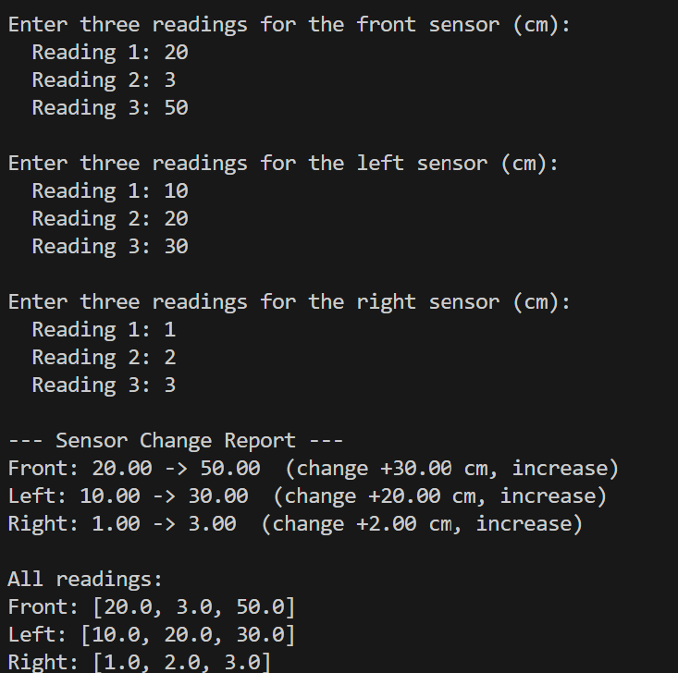

Part 2 - File I/O for Patrol Logging
Robots often log their readings to files in CSV (comma-separated values) format. CSV is easy to write, read, and process.
Code Example:
import csv
# Writing to CSV
with open("log.csv", "w", newline="") as file:
writer = csv.writer(file)
writer.writerow(["front", "left", "right"])
writer.writerow([12.5, 8.3, 14.1])
writer.writerow([11.8, 8.5, 13.7])
# Reading from CSV
with open("log.csv", "r") as file:
reader = csv.reader(file)
for row in reader:
print(row)

Note: The above code demonstrates how to write to and read from a CSV file using Python's built-in csv module.
- It first opens (or creates) a file called log.csv for writing. It writes a header row ("front", "left", "right") and two rows of numeric data.
- Then, it opens the same file for reading, reads each row, and prints it to the console.

Exercise 2:
Create log_readings.py:
1. Ask the user for 3 readings each for front, left, and right sensors.
2. Save the data to a CSV file called log.csv with headers.
3. Read the CSV file back and reconstruct a dictionary with the readings.

Your program's output should look like this:
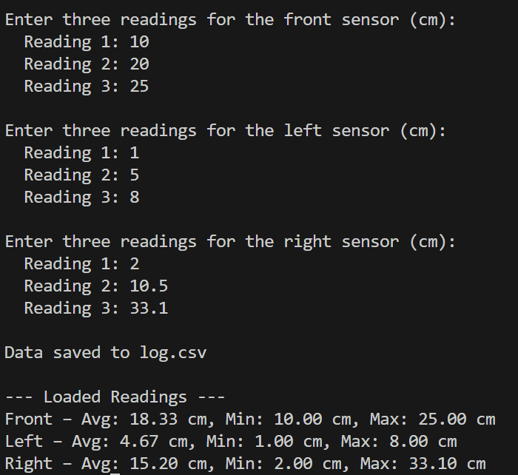

Your log.csv should look have corresponding numbers like this:
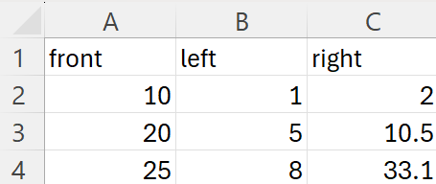

PART 3 – Simulating Sensor Noise and Glitches
In real robots, sensors produce noisy data. We can simulate this with random values and add occasional glitches.
Code Example:
import random
def noisy_reading(base):
noise = random.uniform(-0.5, 0.5)
if random.random() < 0.1: # 10% chance of glitch
return 0
return base + noise
print(noisy_reading(12))

Run the above code several times to see noisy data and the occasional glitch.

Exercise 3:
Create random_patrol.py:
1. Simulate 10 checkpoints.
2. For each checkpoint, generate random base distances (5–25 cm) for front, left, and right sensors.
3. Add ±0.5 cm noise to each reading.
4. 10% chance that any reading is replaced with 0 to simulate a glitch.
5. Print the results in a readable format.

Your program's output should look similar to this (total 10 checkpoints):
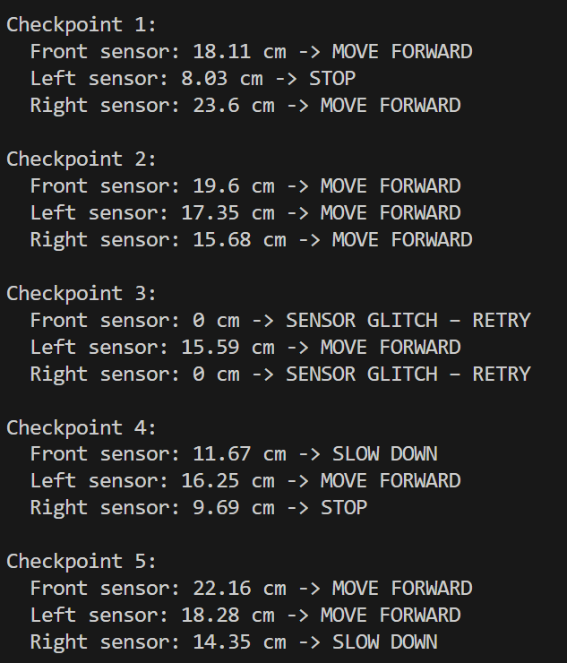

Lab Submission
- Save all your files in a folder named Week 3.
- Commit the folder to your GitHub repository.
- If you haven’t done so already, invite your professor as a collaborator.
- Submit the repository link on D2L Brightspace before the end of the lab session.

